

NOVAC TECHNOLOGY SOLUTIONS

User Manual

Document Version No.: 1.00

Revision History
Version No | Reason For Changes | Author | Approver
0.01 | Draft | Ravi
1.00 | Reviewed & Approved the User Manual | Ravi | NIJANTHAN PL

Table of Contents
1. Introduction 4

2. Auto Raise debit 4

Introduction

This user manual explains about changes incorporated in CTPL SI for Motor and Fleet products in ZIVA Philippines Module.

Exclude the DST amount in the refund amount

- As per the new requirement “Auto Debit Credit Period Due Date” based on the policy start date and payment terms captured against the proposal ..

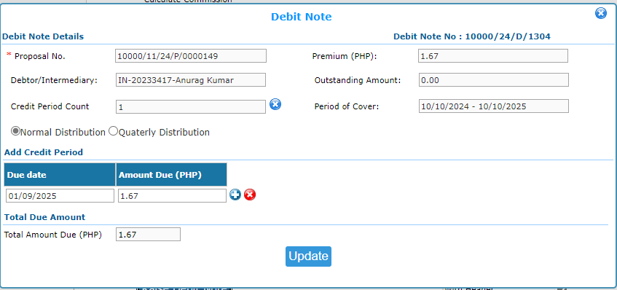
When clicking the "Raise Debit" button, System should automatically populate the credit period count as “1” and the PPW due date based on the “policy start date” and the number of days entered in the “payment terms” field.

